Experience
RCS REHABILITATION SERVICES WHITBY ONT JUNE 2013. PRESENT REHABILITATION SUPPORT WORKER CATASTROPHIC INJURY-PERSONAL TRAINER
Assisting, supporting and implementing outlined programs and goals while promoting appropriate levels of supervision and independence. Observe and monitor behaviors of client and provide detailed written feedback to the supervising regulated health care professional. Community reintegration programs and facilitation with physiotherapist, occupational therapist and speech language pathologist. Programming to assist clients to successfully integrate themselves into their home and community environment as safe and independently as possible.
WHITBY BOOTCAMP INSTRUCTOR WHITBY/PICKERING ONT JULY 2012-PRESENT
Plan and instruct weekly classes focusing on strengthening and challenging the cliental. Modify exercises for different exercise levels or injuries.

Lawlor therapy services inc Mississauga ONT 2005-2013
REHABILITATION SUPPORT WORKER - CATASTROPHIC INJURY
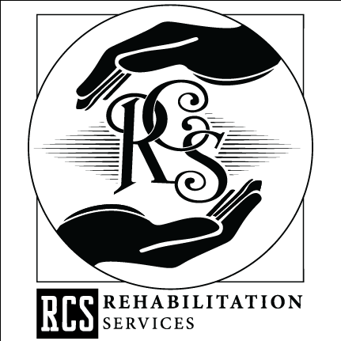
Assisting and supporting in the development of activities of daily living while promoting appropriate levels of independence. Observe and monitor behaviors of client and provide detailed written feedback to the supervising regulated health care professional. Community reintegration programs and facilitation with physiotherapist, occupational therapist and speech language pathologist programming to assist clients to successfully integrate themselves into their home and community environment as safe and independently as possible.

sibley and Associates Inc burlington,ont 2004-2007
INDEPENDENT CONTRACTOR, OCCUPATIONAL THERAPIST ASSISTANT
Work with the attending occupational therapists assisting with development of programs from assessment goals. Management of caseload and booking treatment sessions. Following outlined treatment plans in community. Equipment management, education and ordering.

providence centre GERIATRIC REHABILITATION Toronto, ont 2002-2004
REHABILITATION THERAPIST ASSISTANT
Independent planning and organizing group /one to one treatment. Community home visits and community accessibility, dressing and hygiene programs, equipment maintenance, management education and ordering. Management of caseload and booking appointments. Daily SOAP documentation.

Education
Humber College, Toronto Occupational Therapist Assistant Certificate 2002

Certifications
CanFitPro Personal Trainer and Fitness Instructor 1998
The Ontario Brain Injury Association in Conjunction with Brock University, :Assisting Recovery and Function in Everyday Life Following a Brain Injury 2008
Standard First Aid, CPR/AED Level C Current
CPI Certification, Crises prevention and Intervention Current

References
AVAILABLE UPON REQUEST

